EMFT
(UE24EE242B)
Unit 1
Electrostatics
QB
Coulomb’s Law, Electric Field and Electric Force:
- State Coulomb’s Law in Vector form and obtain the expression for Electrostatic Force and Electric Field at a point due to N number of charges.
Numerical on Coulomb’s Law, Electric Field and Electric Force:
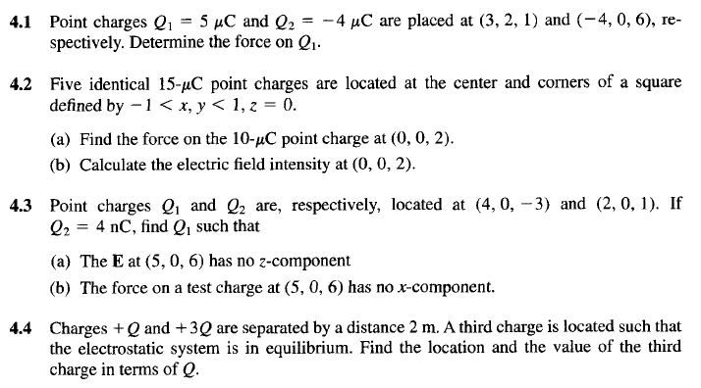
4.5
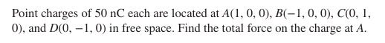
4.6
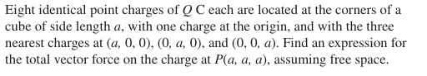

4.7
4.8 Point charges 5 nC and -2 nC are located at (2,0, 4) and (-3,0, 5), respectively.
(a) Determine the force on a 1nC point charge located at (1, -3, 7).
(b) Find the electric field E at (1, - 3, 7).
4.9 A charge of -10 nC is placed at origin and a charge Q C is placed at (2, 0, 0). If X
Component of Electric field E is Zero at (3, 1, 1), Then find Q.
4.10 Three equal point charges of 2µC are placed at (0,0,0), (2,0,0) and (0,2,0). Find the
Electrostatic Force on 5 µC placed at (2, 2, 0).

